EXPERIMENT NO. 6
Payroll Processing System using Zoho Creator (SaaS)

Aim
To develop a cloud-based Payroll Processing System using Zoho Creator to manage employee payroll details.

Objective
Create a SaaS payroll application, store employee details, maintain salary details and generate reports.

Software Requirements
Zoho Creator, Google Chrome, Internet Connection.

Theory
The Payroll Processing System is a SaaS application that stores employee information and payroll details. It maintains employee name, ID, department, designation, present experience, overall experience, basic pay and can be extended to calculate HRA, DA, TA, Gross Pay and Net Pay.

Fields Used
Employee Name, Employee ID, Department, Designation, Present Experience, Overall Experience, Basic Pay, HRA, DA, TA, Gross Pay, Net Pay.

Algorithm
Start → Enter Employee Details → Enter Salary Details → Calculate Salary Components → Save Record → Generate Report → View Individual Record → Stop.

Procedure
1. Create application.
2. Design form.
3. Add payroll fields.
4. Save form.
5. Enter records.
6. Generate report.
7. Verify records.

Observation
Employee details were stored successfully. Payroll information was recorded. Reports displayed all records. Individual employee information was displayed correctly.

Result
Payroll Processing System was successfully implemented using Zoho Creator.

Conclusion
The experiment demonstrated a cloud-based SaaS payroll management application.

Figure 1: Payroll Form
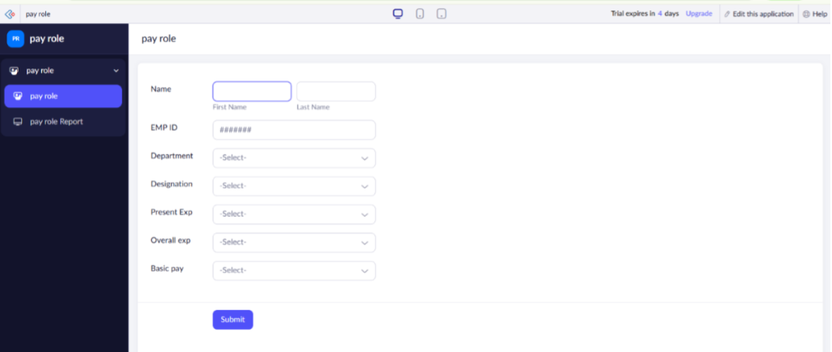

Figure 2: Payroll Report
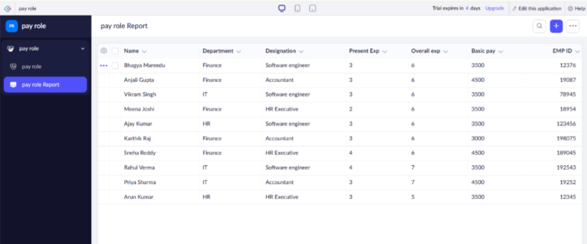

Figure 3: Employee Record
